Word | Definition | Use the word in a sentence
Sub- regions

Physical features

Hierarchy

Rural

Suburban

Urban

Interdependence

Accessibility

Complementarity

Diffusion

Directions: Identify the vocabulary word that matches the picture. Explain the reason why the word matches the picture.
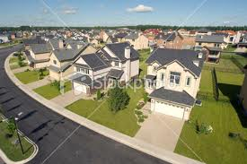
Word: Word: Word:
Reason: Reason: Reason:

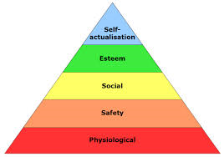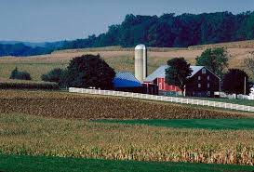
Word: Word: Word:
Reason: Reason: Reason:

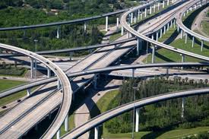
Word:
Reason:

